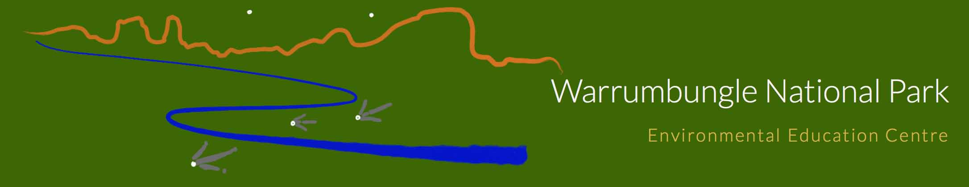

KLA | Geography
Title | Landscapes and Landforms
Suitable for stages | Stage 4
Key Inquiry Questions | - Why is there a diversity of landscapes and landforms in the Warrumbungle National Park (W.N.P.)?  - What environmental and human processes have formed and transformed landscapes and landforms in the W.N.P.?  - Why do people value landscapes and landforms in the W.N.P.?  - To what extent are landscapes and landforms sustainably managed and protected within the W.N.P.?
Location | WNPEEC and Surrounding Areas
Duration | 2 day
Outcomes | Content Focus
- locates and describes the diverse features and characteristics of a range of places and environments GE4-1  - describes processes and influences that form and transform places and environments GE4-2  - discusses management of places and environments for their sustainability GE4-5  - acquires and processes geographical information by selecting and using geographical tools for inquiry GE4-7  - communicates geographical information using a variety of strategies GE4-8 | Students explore landscapes and landforms using examples from Australia and throughout the world. They explain processes that create landscapes and shape individual landforms and they describe the value of landscapes and landforms to different people. Students examine issues of landscape degradation and ways to manage and protect landscapes and landforms. Students also investigate a natural hazard associated with landscapes and people’s responses to that hazard.
Procedure
Safety:
Written up by:

